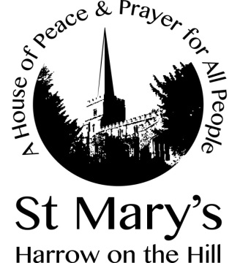

The Feast of Corpus Christi
Thursday 11 June 2020

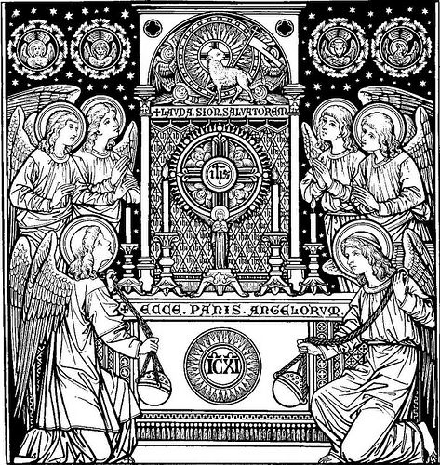
The Greeting

In the name of the Father, and of the Son, and of the Holy Spirit. Amen.

Prayer of Preparation

Almighty God, to whom all hearts are open, all desires known, and from whom no secrets are hidden: cleanse the thoughts of our hearts by the inspiration of your Holy Spirit, that we may perfectly love you, and worthily magnify your holy name; through Christ our Lord. Amen.

Please sit or kneel
Prayers of Penitence

Whoever eats the bread or drinks the cup of the Lord in an unworthy manner eats and drinks judgement upon themselves. Examine yourselves, therefore, and call to mind your sins.
cf 1 Corinthians 11.27-29

Lord Jesus, you raise us to new life:
Lord, have mercy.
Lord Jesus, you forgive our sins:
Christ, have mercy.
Lord Jesus, you feed us with your body and blood:
Lord, have mercy.

May the God of love and power forgive you and free you from your sins,
heal and strengthen you by his Spirit and raise you to new life in Christ our Lord. Amen.

Opening Hymn

296 Lord enthroned in heavenly splendour

THE LITURGY OF THE WORD

The Collect

Lord Jesus Christ, we thank you that in this wonderful sacrament you have given us the memorial of your passion: grant us so to reverence the sacred mysteries of your body and blood that we may know within ourselves and show forth in our lives the fruits of your redemption; for you are alive and reign with the Father in the unity of the Holy Spirit, one God, now and for ever. Amen.
New Testament Reading

For I received from the Lord what I also handed on to you, that the Lord Jesus on the night when he was betrayed took a loaf of bread, and when he had given thanks, he broke it and said, “This is my body that is for you. Do this in remembrance of me.” In the same way he took the cup also, after supper, saying, “This cup is the new covenant in my blood. Do this, as often as you drink it, in remembrance of me.” For as often as you eat this bread and drink the cup, you proclaim the Lord’s death until he comes.

1 Corinthians 11:23-26

This is the word of the Lord.
Thanks be to God.

Psalm 116:10-end

I kept my faith, even when I said,
“I am greatly afflicted”;
11 I said in my consternation,
“Everyone is a liar.”

12 What shall I return to the Lord
for all his bounty to me?
13 I will lift up the cup of salvation
and call on the name of the Lord,
14 I will pay my vows to the Lord
in the presence of all his people.
15 Precious in the sight of the Lord
is the death of his faithful ones.
16 O Lord, I am your servant;
I am your servant, the child of your serving girl.
You have loosed my bonds.
17 I will offer to you a thanksgiving sacrifice
and call on the name of the Lord.
18 I will pay my vows to the Lord
in the presence of all his people,
19 in the courts of the house of the Lord,
in your midst, O Jerusalem.
Praise the Lord!

Gradual Hymn

272 All for Jesus

Gospel Acclamation

Alleluia, alleluia. I am the living bread that came down from heaven, says the Lord. Whoever eats of this bread will live for ever. John 6.51 Alleluia.
The Gospel

When the Gospel is announced the reader says
Hear the Gospel of our Lord Jesus Christ according to John
Glory to you, O Lord.

I am the living bread that came down from heaven. Whoever eats of this bread will live forever; and the bread that I will give for the life of the world is my flesh.”
The Jews then disputed among themselves, saying, “How can this man give us his flesh to eat?” So Jesus said to them, “Very truly, I tell you, unless you eat the flesh of the Son of Man and drink his blood, you have no life in you. Those who eat my flesh and drink my blood have eternal life, and I will raise them up on the last day; for my flesh is true food and my blood is true drink. Those who eat my flesh and drink my blood abide in me, and I in them. Just as the living Father sent me, and I live because of the Father, so whoever eats me will live because of me. This is the bread that came down from heaven, not like that which your ancestors ate, and they died. But the one who eats this bread will live forever.”

John 6:51-58

This is the Gospel of the Lord.
Praise to you, O Christ.

Prayers of Intercession

THE LITURGY OF THE SACRAMENT

The Peace

Our Lord Jesus Christ says: If, when you are bringing your gift to the altar, you remember your brother or sister has a grievance against you, leave your gift where it lies before the altar. Go, make peace; and only then come and offer your gift.

The peace of the Lord be always with you
and also with you.

Offertory Hymn

302 O Thou who at thy Eucharist didst pray

Be present, be present,
Lord Jesus Christ,
our risen high priest;
make yourself known in the breaking of bread.
Amen.
The Eucharistic Prayer

The Lord be with you
and also with you.
Lift up your hearts.
We lift them to the Lord.
Let us give thanks to the Lord our God.
It is right to give thanks and praise.

It is indeed right and good, our duty and our salvation always and everywhere to give you thanks and praise holy Father, almighty and eternal God, through Jesus Christ our great high priest. He offered himself to you as the Lamb without blemish, the acceptable gift that gives you perfect praise. At the Last Supper, seated with his apostles, he left this memorial of his passion to bring us its saving power until the end of time. In this great sacrament you feed your people and strengthen them in holiness, so that throughout the world the human family may be enlightened by one faith and drawn together in one communion of love. We come to this foretaste of your heavenly banquet to be transformed by your grace and restored in the image and likeness of the risen Christ. Therefore earth unites with heaven to sing a new song of praise; we too join with angels and archangels as they proclaim your glory without end:
Holy, holy, holy Lord,
God of power and might,
heaven and earth are full of your glory.
Hosanna in the highest.
Blessed is he who comes in the name of the Lord.
Hosanna in the highest.

Accept our praises, heavenly Father, through your Son our Saviour Jesus Christ, and as we follow his example and obey his command, grant that by the power of your Holy Spirit these gifts of bread and wine may be to us his body and his blood; who, in the same night that he was betrayed, took bread and gave you thanks; he broke it and gave it to his disciples, saying:

Take, eat; this is my body which is given for you;
do this in remembrance of me.

In the same way, after supper he took the cup and gave you thanks; he gave it to them, saying:

Drink this, all of you; this is my blood of the new covenant, which is shed for you and for many for the forgiveness of sins. Do this, as often as you drink it, in remembrance of me.

Therefore, heavenly Father, We remember his offering of himself made once for all upon the cross; we proclaim his mighty resurrection and glorious ascension; we look for the coming of your kingdom, and with this bread and this cup we make the memorial of Christ your Son our Lord.

Great is the mystery of faith:
Christ has died:
Christ is risen:
Christ will come again.

Accept through him, our great high priest, this our sacrifice of thanks and praise, and as we eat and drink these holy gifts in the presence of your divine majesty, renew us by your Spirit, inspire us with your love
and unite us in the body of your Son, Jesus Christ our Lord.

Through him, and with him, and in him, in the unity of the Holy Spirit, with all who stand before you in earth and heaven, we worship you, Father almighty, in songs of everlasting praise:

Blessing and honour and glory and power
be yours for ever and ever.
Amen.

The Lord’s Prayer

Let us pray with confidence as our Saviour has taught us
Our Father, who art in heaven, hallowed be thy name; thy kingdom come; thy will be done; on earth as it is in heaven. Give us this day our daily bread. And forgive us our trespasses, as we forgive those who trespass against us. And lead us not into temptation; but deliver us from evil. For thine is the kingdom, the power and the glory, for ever and ever. Amen.

Breaking of the Bread

We break this bread to share in the body of Christ.
Though we are many, we are one body,
because we all share in one bread.

The Agnus Dei

Lamb of God, you take away the sin of the world,
have mercy on us.
Lamb of God, you take away the sin of the world,
have mercy on us.
Lamb of God, you take away the sin of the world,
grant us peace.

The Act of Spiritual Communion

Communion Hymn

295 Let all mortal flesh keep silence

The Blessing
May the Father, who fed his children with manna in the wilderness, strengthen you in your pilgrimage to the Promised Land.
Amen.

May the Son, who gave his flesh for food and his blood for drink, keep you in eternal life and raise you up on on the last day.
Amen.

May the Holy Spirit, who leads us into all truth, help you discern the Lord’s body and empower you to proclaim his death until he comes. Amen.

And the blessing of God almighty, the Father, the Son, and the Holy Spirit, be among you and remain with you always. Amen.

Please stand
Post Communion Hymn

310 We hail thy presence glorious

The Dismissal

Then their eyes were opened, and they recognized him. He had been made known to them in the breaking of the bread.
Thanks be to God. Alleluia, alleluia.

