The Parish & Borough Church of St Mary
Harrow on the Hill

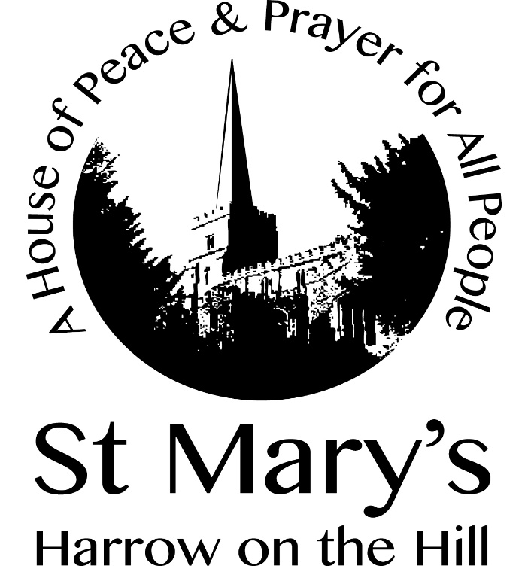

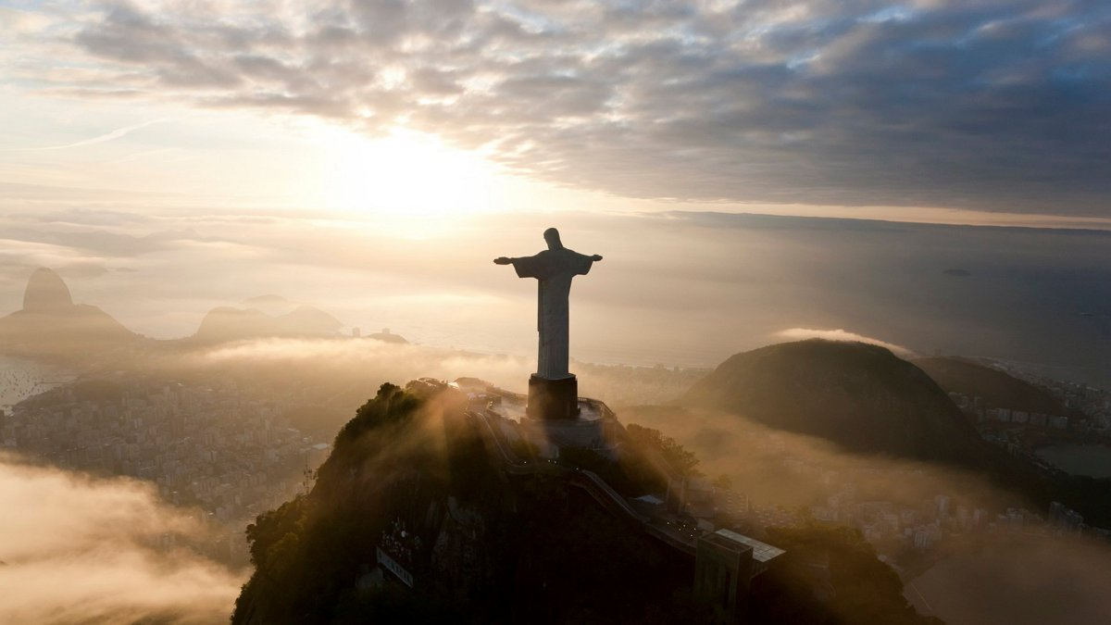

Ascension Day Eucharist
Thursday 21th May 2020
Introduction

In the name of the Father, Son and Holy Spirit.
Amen.

Dear brothers and sisters in Christ, for forty days we have been celebrating with joyful hearts the resurrection of our Lord Jesus Christ, his bursting from the tomb and his defeat of the power of sin and death. He appeared to his disciples many times and told them about the kingdom of God. Today we recall how he left this earth and returned to his Father, ascending into heaven to take his throne over all dominions and powers. Trusting in his reign over all creation, and submitting to his kingly yet loving rule, let us hear the story of his parting.

A reading from the Acts of the Apostles

While staying with them, he ordered them not to leave Jerusalem, but to wait there for the promise of the Father. ‘This’, he said, ‘is what you have heard from me; for John baptized with water, but you will be baptized with the Holy Spirit not many days from now.’ So when they had come together, they asked him, ‘Lord, is this the time when you will restore the kingdom to Israel?’ He replied, ‘It is not for you to know the times or periods that the Father has set by his own authority. But you will receive power when the Holy Spirit has come upon you; and you will be my witnesses in Jerusalem, in all Judea and Samaria, and to the ends of the earth.’ When he had said this, as they were watching, he was lifted up, and a cloud took him out of their sight. While he was going and they were gazing up towards heaven, suddenly two men in white robes stood by them. They said, ‘Men of Galilee, why do you stand looking up towards heaven? This Jesus, who has been taken up from you into heaven, will come in the same way as you saw him go into heaven.’

1.4-11

Alleluia. Christ is risen.
He is risen indeed. Alleluia.

Hymn

Hail the day that sees him rise

The Collect

Grant, we pray, almighty God, that as we believe your only-begotten Son our Lord Jesus Christ to have ascended into the heavens, so we in heart and mind may also ascend and with him continually dwell; who is alive and reigns with you, in the unity of the Holy Spirit, one God, now and for ever. Amen

New Testament Reading

I have heard of your faith in the Lord Jesus and your love toward all the saints, and for this reason I do not cease to give thanks for you as I remember you in my prayers. I pray that the God of our Lord Jesus Christ, the Father of glory, may give you a spirit of wisdom and revelation as you come to know him, so that, with the eyes of your heart enlightened, you may know what is the hope to which he has called you, what are the riches of his glorious inheritance among the saints, and what is the immeasurable greatness of his power for us who believe, according to the working of his great power. God put this power to work in Christ when he raised him from the dead and seated him at his right hand in the heavenly places, far above all rule and authority and power and dominion, and above every name that is named, not only in this age but also in the age to come. And he has put all things under his feet and has made him the head over all things for the church, which is his body, the fullness of him who fills all in all.
Ephesians 1:15-23

Gradual Hymn

The head that once was crowned with thorns

The Gospel

Hear the Gospel of our Lord Jesus Christ according to Luke.
Glory to you, O Lord.

Then he said to them, “These are my words that I spoke to you while I was still with you—that everything written about me in the law of Moses, the prophets, and the psalms must be fulfilled.” Then he opened their minds to understand the scriptures, and he said to them, “Thus it is written, that the Messiah is to suffer and to rise from the dead on the third day, and that repentance and forgiveness of sins is to be proclaimed in his name to all nations, beginning from Jerusalem. You are witnesses of these things. And see, I am sending upon you what my Father promised; so stay here in the city until you have been clothed with power from on high.”

Then he led them out as far as Bethany, and, lifting up his hands, he blessed them. While he was blessing them, he withdrew from them and was carried up into heaven. And they worshiped him, and returned to Jerusalem with great joy; and they were continually in the temple blessing God.

This is the Gospel of the Lord.
Praise to you, O Christ.

Creed

Let us affirm our faith in Jesus Christ the Son of God.

Though he was divine, he did not cling to equality with God, but made himself nothing. Taking the form of a slave, he was born in human likeness. He humbled himself and was obedient to death, even the death of the cross. Therefore God has raised him on high, and given him the name above every name: that at the name of Jesus every knee should bow, and every voice proclaim that Jesus Christ is Lord, to the glory of God the Father. Amen.

Intercessions

God of our salvation, hope of all the ends of the earth,
we pray:
Thy kingdom come.

That the world may know Jesus Christ as the Prince of Peace,
we pray:
Thy kingdom come.

That the Church may be one in serving and proclaiming the gospel, we pray:
Thy kingdom come.

That we may be bold to speak the word of God while you stretch out your hand to save, we pray:
Thy kingdom come.

That the Church may be generous in giving, faithful in serving, bold in proclaiming, we pray:
Thy kingdom come.

That the Church may welcome and support all whom God calls to faith, we pray:
Thy kingdom come.

That all who suffer for the gospel may know the comfort and glory of Christ, we pray:
Thy kingdom come.

That the day may come when every knee shall bow and every tongue confess that Jesus Christ is Lord, we pray:
Your kingdom come.

The Peace

Jesus says: ‘Peace I leave with you; my peace I give to you. If you love me, rejoice because I am going to the Father’. Alleluia.

The peace of the Lord be always with you.
And also with you.

Offertory Hymn

And can it be that I should gain

The Eucharistic Prayer

The Lord be with you
And also with you
Lift up your hearts
We lift them to the Lord
Let us give thanks to the Lord our God
It is right to give thanks and praise

It is indeed right and good, our duty and our joy, always and everywhere to give you thanks, holy Father, almighty and eternal God, through Jesus Christ the King of glory. Born of a woman, he came to the rescue of our human race. Dying for us, he trampled death and conquered sin. By the glory of his resurrection he opened the way to life eternal and by his ascension, gave us the sure hope that where he is we may also be. Therefore the universe resounds with Easter joy and with choirs of angels we sing for ever to your praise:

Holy, holy, holy Lord, God of power and might, heaven and earth are full of your glory. Hosanna in the highest. Blessed is he who comes in the name of the Lord. Hosanna in the highest.

How wonderful the work of your hands, O Lord. As a mother tenderly gathers her children, you embraced a people as your own. When they turned away and rebelled your love remained steadfast. From them you raised up Jesus our Saviour, born of Mary, to be the living bread, in whom all our hungers are satisfied. He offered his life for sinners, and with a love stronger than death he opened wide his arms on the cross.

On the night before he died, he came to supper with his friends and, taking bread, he gave you thanks. He broke it and gave it to them, saying: Take, eat; this is my body which is given for you; do this in remembrance of me.
At the end of supper, taking the cup of wine, he gave you thanks, and said: Drink this, all of you; this is my blood of the new covenant, which is shed for you and for many for the forgiveness of sins. Do this, as often as you drink it, in remembrance of me.

Great is the mystery of faith:
Christ has died: Christ is risen: Christ will come again.

Father, we plead with confidence his sacrifice made once for all upon the cross; we remember his dying and rising in glory, and we rejoice that he intercedes for us at your right hand. Pour out your Holy Spirit as we bring before you these gifts of your creation; may they be for us the body and blood of your dear Son. As we eat and drink these holy things in your presence, form us in the likeness of Christ, and build us into a living temple to your glory.

Bring us at the last with the Blessed Virgin Mary, St Anselm and all the saints to the vision of that eternal splendour for which you have created us; through Jesus Christ, our Lord, by whom, with whom, and in whom, with all who stand before you in earth and heaven, we worship you, Father almighty, in songs of everlasting praise:

Blessing and honour and glory and power be yours for ever and ever. Amen

The Lord’s Prayer

Looking for the coming of his kingdom, let us pray with confidence as our Saviour has taught us
Our Father, who art in heaven, hallowed be thy name; thy kingdom come; thy will be done; on earth as it is in heaven. Give us this day our daily bread. And forgive us our trespasses, as we forgive those who trespass against us. And lead us not into temptation; but deliver us from evil. For thine is the kingdom, the power and the glory, for ever and ever. Amen.

The Breaking of the Bread

Lord, we died with you on the cross.
Now we are raised to new life.
We were buried in your tomb.
Now we share in your resurrection.
Live in us, that we may live in you.

Invitation to Communion

I heard the voice of a great multitude crying, Alleluia.
The Lord our God has entered into his kingdom.
Blessed are those who are called to the supper of the Lamb. Alleluia

Hymn

Crown him with many crowns

The Blessing

God the Father, who has given to his Son the name above every name, strengthen you to proclaim Christ Jesus as Lord. Amen.
God the Son, who is our great high priest passed into the heavens, plead for you at the right hand of the Father.
Amen.
God the Holy Spirit, who pours out his abundant gifts upon the Church, make you faithful servants of Christ our King. Amen.
And the blessing of God almighty, the Father, the Son, and the Holy Spirit, be among you and remain with you always. Amen.

The Dismissal

Waiting expectantly for the promised Holy Spirit, go in the peace of Christ. Alleluia, alleluia.
Thanks be to God. Alleluia, alleluia.

